**Assignment 3 - Practicing Directives**

The last assignment for this course section. Practice what you learned about Directives and use the most common Directives on your own!

The snapshot below explains the example app you're starting with and which tasks should be completed as part of this assignment.

Make sure to also answer why you implemented the solution you chose to use.

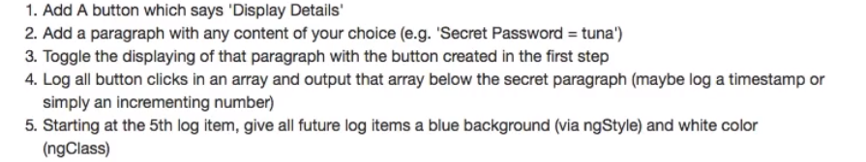

**Questions for this assignment**

**Please complete the tasks outlined in the instructions below. Why did you choose the approach you took? Which problems did you encounter?**

**Download resource files**

* basics-assignment-3-start.zip